**4. SYSTEM FEATURES**

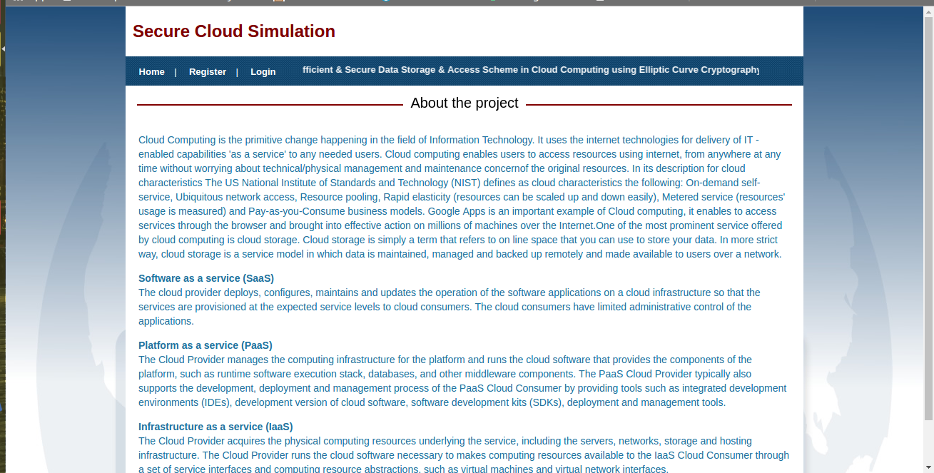

Fig. 11

This is the **landing page** of the web application – the very first page which is visible when the app is launched in the browser of the user’s system. This page lets the user know about the application and let the user to choose between first time registration and login features. Along with this, the page contains tabs for download and upload section also. It contains, app logo, tag line and makes the user aware about the goal of the application is short period of time and enhances aesthetic value.

22

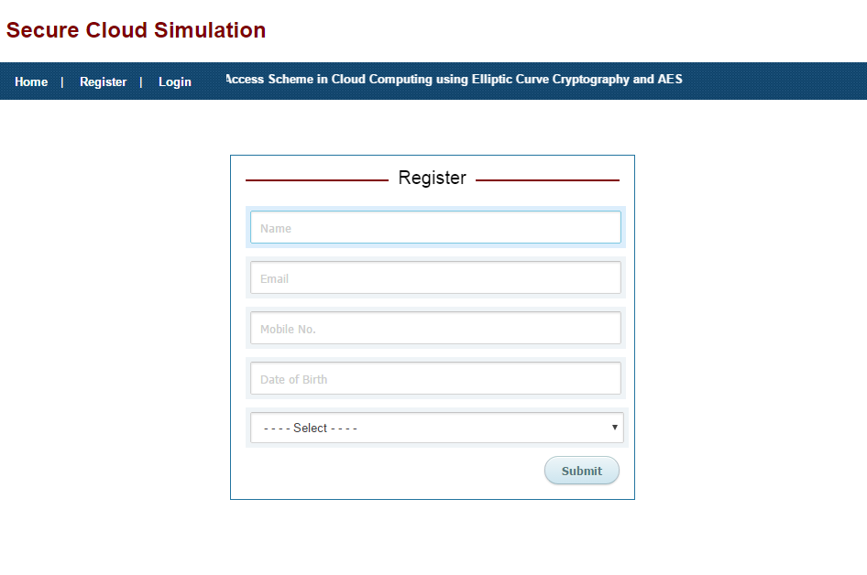

Fig. 12

This is the **Registration Page** of the application which is displayed when user is using the application for the first time or does not possess a user account.

The form here takes user’s full name, email address, mobile number, DOB and gender as input to store user’s information and validate the user before giving access to the app data. It first checks for all possible errors in the credentials on the client side itself using regular expressions and pattern matching. Later, if the data passes all the test cases, it is sent to server side to validate and store the details in the database to create a working profile of the user.

23

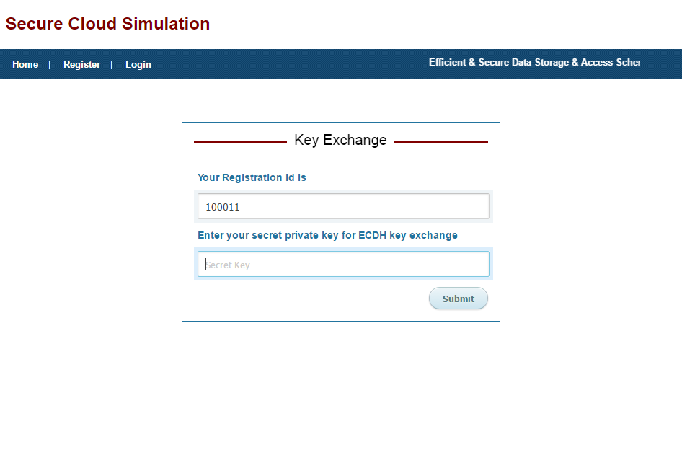

Fig. 13

This is the **Key Exchange** page of the application. Using ECC algorithm, public key and private key both are generated. Here Sender will be used to encrypt the data and receiver i.e. B is used to decrypt the data by using its own private key. The form here takes, registration number along with secret key for successful key exchange.

24

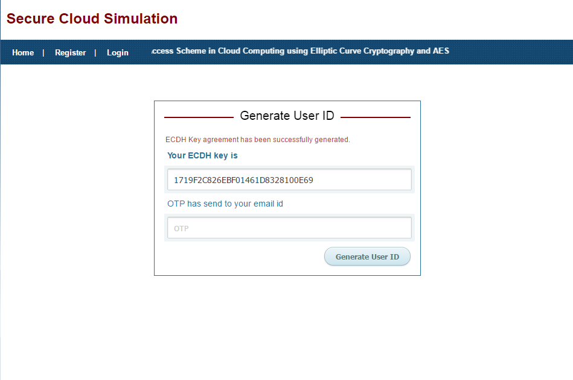

Fig. 14

This is the 3rd stage of Registration process itself. Here ECDH key agreement has been automatically generated successfully and **OTP (one time password)** is sent to the email address given by the user on stage one of the registration. The app takes OTP as input and after proper validation of both the fields, it passes the control to the next stage of new user registration.

25

Fig. 15

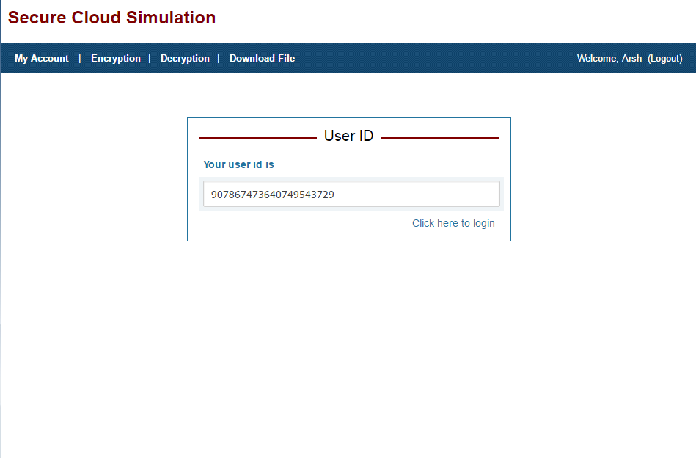

On successful validation, the application generates a unique **User ID**. The user is requested to save this ID as, once the registration is done, the user will be using just the User ID generated here and the secret key entered earlier to use all the features and perform validation further in the application. The new user registration completes here and now the user can easily login to access his profile and use all the features of the application.

26

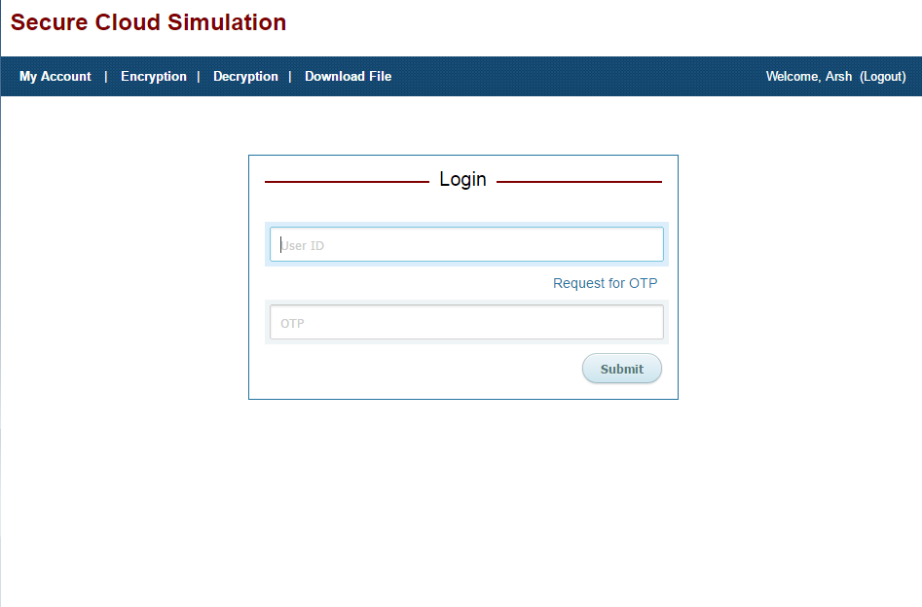

Fig. 16

This is the **Login page** of the application which is loaded when the user clicks on the login tab button. The page consists of a simple form which inputs the User ID of the user generated during registration process and the OTP which is immediately sent to the user’s email address as soon as he clicks on ‘Request for OTP’ button in the form. Later, both the values in the fields are validated over the server with the values in the database and if successful the user is taken to the next page that is Dashboard of the application, else error is generated.

27

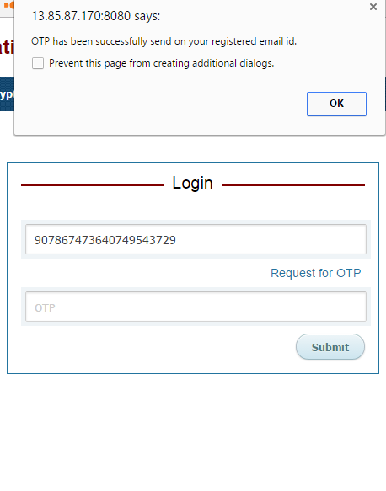

Fig. 17

Here a confirmation message is shown to verify that the OTP is successfully delivered to the registered email ID of the user.

28

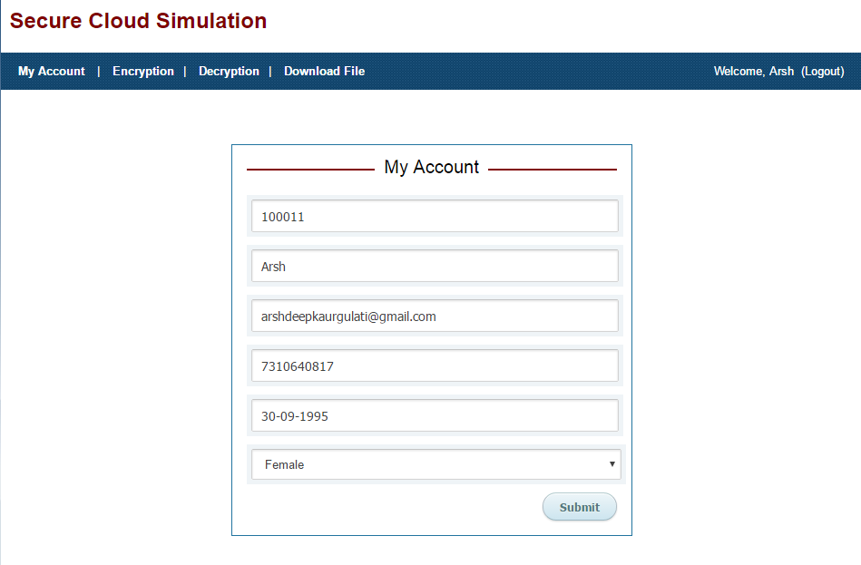

Fig. 18

This is the **Dashboard Page** of the application. When the user is able to successfully login into the app for the first time, he is taken to the My Account section where he is shown the current details of his account stored in the database and is given an opportunity to update any field if required and click on submit button to save. The dashboard page serves as a navigating page as from here the user can go-to encryption, decryption download and upload sections and can log out from the app if the work is done.

29

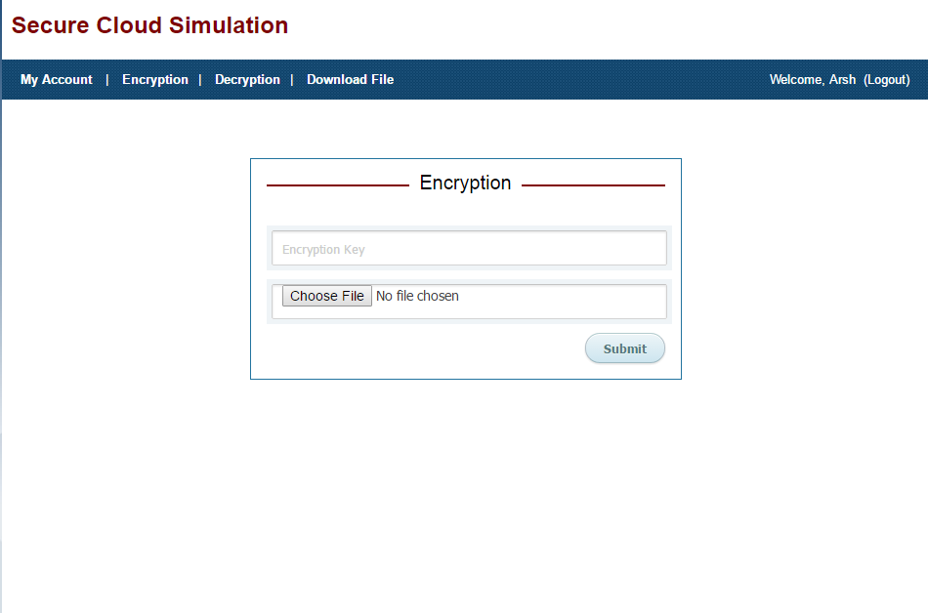

Fig. 19

This is the **File Encryption** page of the application. If the user wishes to upload a file in the cloud application and encrypt it to ensure security, he would hit the encryption tab. Next he is asked to enter the Encryption key which is actually the same secret key entered at the time of registration also. After that, he is asked to select the file to be uploaded from his local system on which the application is running. Lastly, click on submit to process the encryption and saving of file.

30

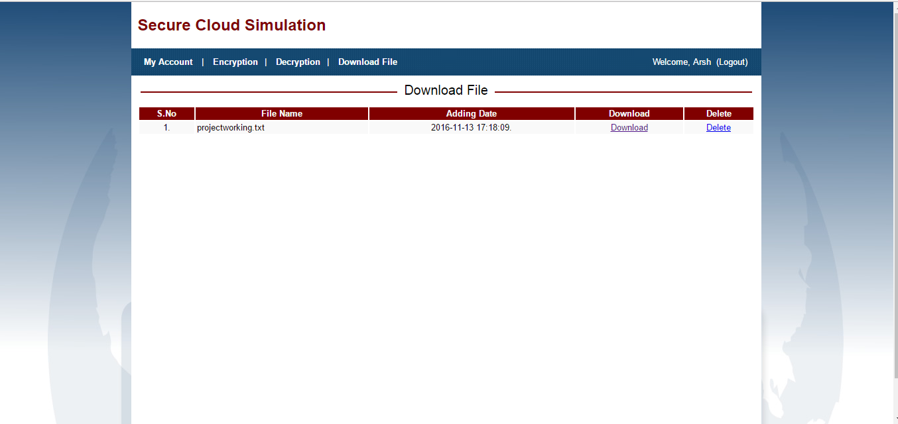

Fig. 20

This is the final dashboard of the user’s account. Now after the encryption and uploading of the file is completed, the user can go to the decryption section, enter the respective AES key that was generated and given to him, and select the file to download. After this, the chosen file is decrypted and ready for download. The downloading would start as soon as the user hits the download button.

31